How use ESRI FGDB in QGIS

Step 1) Open dialog for adding a new vector layer (Layer/Add layer/Add vector layer)

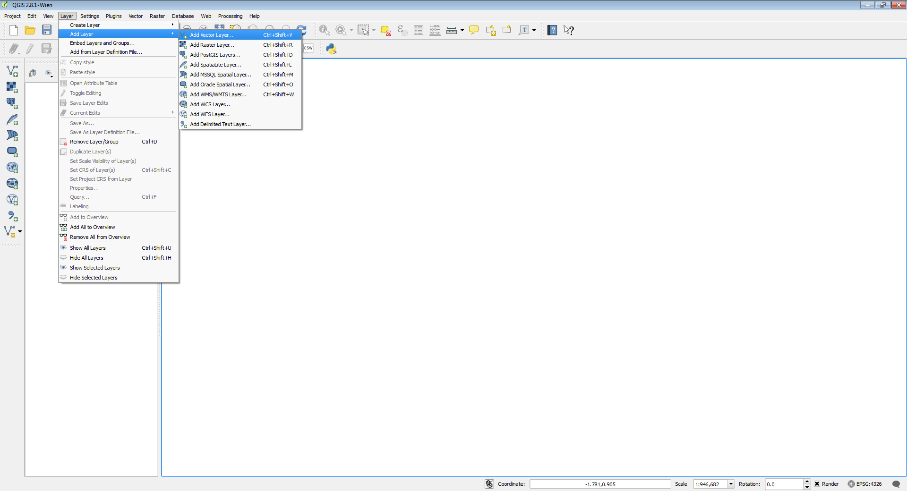

Step 2) In the Add vector layer dialog select
- Directory option in the Source type part of the dialog
- OpenFileGDB as Type in the Source part of the dialog

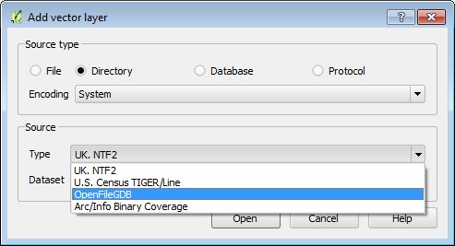

Step 3) Browse source ArcGIS file geodatabase and click Open

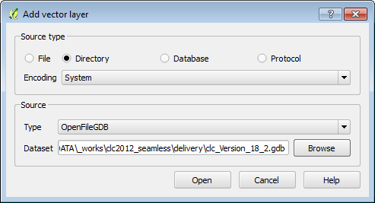

Step 4)
Select layer from the list and click OK

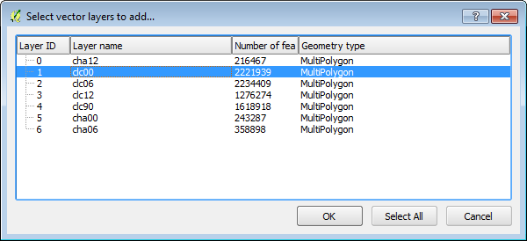

Layer is added to the map window.

Step 5) Double click to the layer name - layer properties window will be open

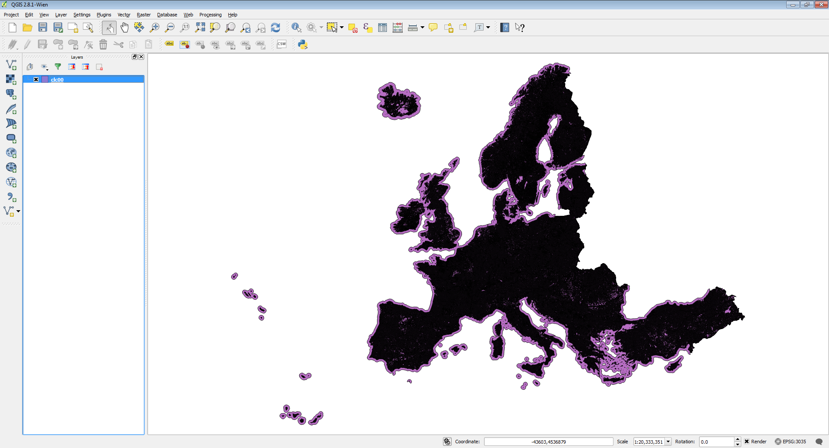
Double click here

Step 6) Select Style bookmark and click to Style button

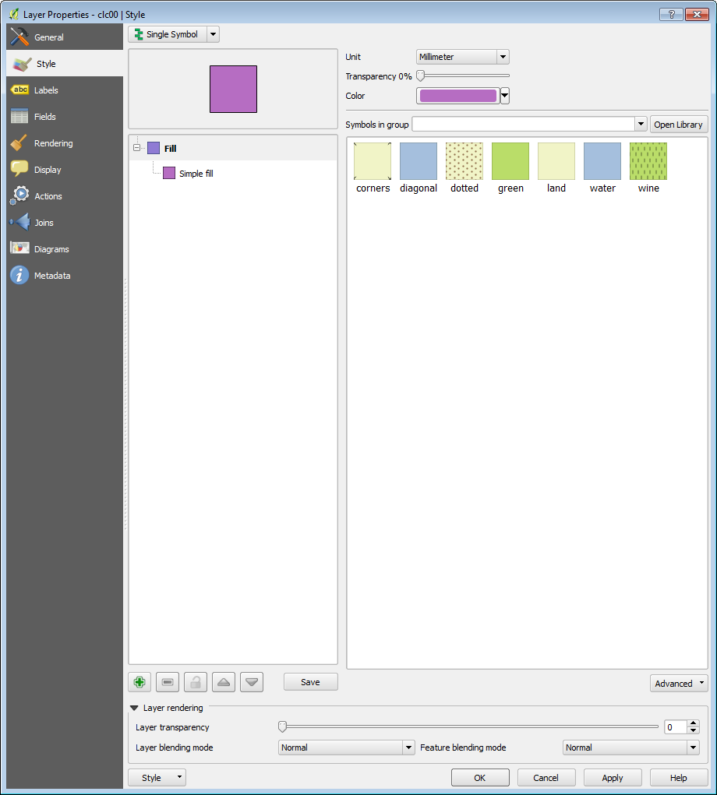

Step 7) Select Load Style from pop-up menu

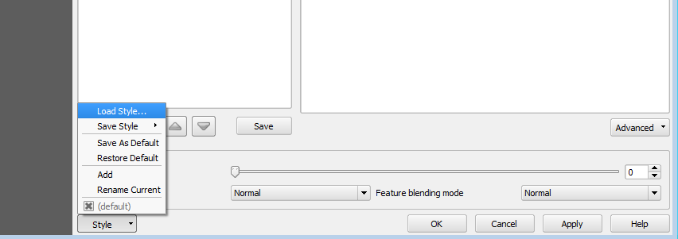

Step 8) Browse clc_legend.qml file, select it and click Open button. Layer style will be changed

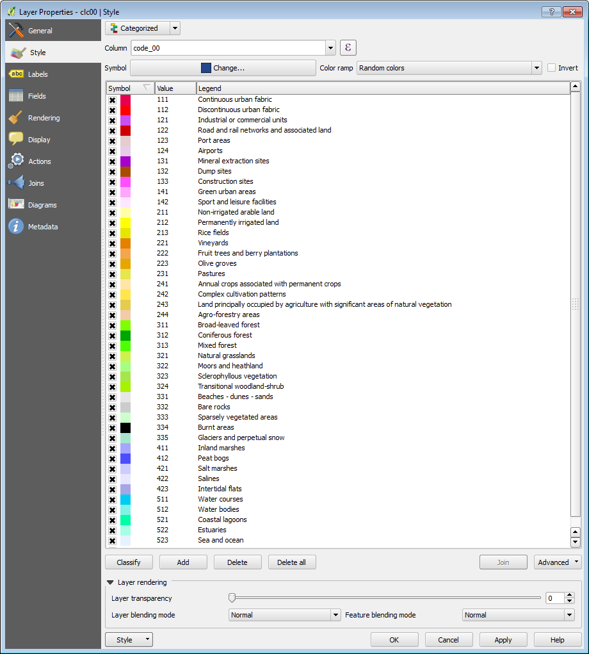

Step 9) Click Ok and layer symbology will be changed

